UNITED STATES
SECURITIES AND EXCHANGE COMMISSION
WASHINGTON, D.C. 20549

FORM 8-K

CURRENT REPORT
Pursuant to Section 13 or 15(d) of the Securities Exchange Act of 1934
Date of Report (Date of earliest event reported): July 14, 2026

Runway Growth Finance Corp.
(Exact name of Registrant as Specified in Its Charter)

Maryland |  |  | 814-01180 | 47-5049745
(State or Other Jurisdiction  of Incorporation) |  |  | (Commission File Number) | (IRS Employer  Identification No.)
205 N. Michigan Ave.
Suite 4200
Chicago, Illinois |  |  |  | 60601
(Address of Principal Executive Offices) |  |  |  | (Zip Code)

Registrant’s Telephone Number, Including Area Code: (312) 698-6902

Not Applicable
(Former Name or Former Address, if Changed Since Last Report)

Check the appropriate box below if the Form 8-K filing is intended to simultaneously satisfy the filing obligation of the registrant under any of the following provisions:
☐Written communications pursuant to Rule 425 under the Securities Act (17 CFR 230.425)
☐Soliciting material pursuant to Rule 14a-12 under the Exchange Act (17 CFR 240.14a-12)
☐Pre-commencement communications pursuant to Rule 14d-2(b) under the Exchange Act (17 CFR 240.14d-2(b))
☐Pre-commencement communications pursuant to Rule 13e-4(c) under the Exchange Act (17 CFR 240.13e-4(c))
Securities registered pursuant to Section 12(b) of the Act:
Title of each class |  | Trading  Symbol(s) |  | Name of each exchange on which registered
Common Stock, par value $0.01 per share |  | RWAY |  | Nasdaq Global Select Market
7.50% Notes due 2027 |  | RWAYL |  | Nasdaq Global Select Market
7.25% Notes due 2031 |  | RWAYI |  | Nasdaq Global Select Market
9.00% Notes due 2027 |  | SWKHL |  | Nasdaq Global Select Market
Indicate by check mark whether the registrant is an emerging growth company as defined in Rule 405 of the Securities Act of 1933 (§ 230.405 of this chapter) or Rule 12b-2 of the Securities Exchange Act of 1934 (§ 240.12b-2 of this chapter).
Emerging growth company ☒
If an emerging growth company, indicate by check mark if the registrant has elected not to use the extended transition period for complying with any new or revised financial accounting standards provided pursuant to Section 13(a) of the Exchange Act. ☐

Item 7.01 Regulation FD Disclosure.
On July 14, 2026, Runway Growth Finance Corp. (the "Company") issued a press release announcing its portfolio activity for the quarter ended June 30, 2026. A copy of the press release is furnished herewith as Exhibit 99.1.
Additionally, on July 14, 2026, the Company made available to its shareholders an investor presentation providing a business and capital allocation update. A copy of the presentation is furnished herewith as Exhibit 99.2. A copy of the press release is furnished herewith as Exhibit 99.1.
The information disclosed under this Item 7.01, including Exhibit 99.1 and Exhibit 99.2 hereto, are being furnished and shall not be deemed “filed” for purposes of Section 18 of the Securities Exchange Act of 1934, as amended, and shall not be deemed incorporated by reference into any filing made under the Securities Act of 1933, as amended, except as expressly set forth by specific reference in such filing.

Item 9.01 Financial Statements and Exhibits.
Exhibit Number |  | Description
99.1 |  | Press Release, dated July 14, 2026.
99.2 |  | Runway Growth Finance Corp. Business and Capital Allocation Update.
104 |  | Cover Page Interactive Data File (embedded within the Inline XBRL document)

SIGNATURES
Pursuant to the requirements of the Securities Exchange Act of 1934, the registrant has duly caused this report to be signed on its behalf by the undersigned hereunto duly authorized.
 |  |  | Runway Growth Finance Corp.
Date: | July 14, 2026 | By: | /s/ Carmela Thomson
 |  |  | Chief Financial Officer

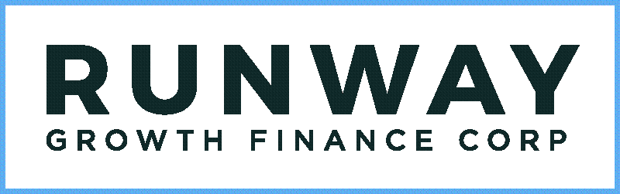

Runway Growth Finance Corp. Provides Second Quarter 2026 Business and Portfolio Update

Adviser and affiliates commit to purchase up to 10% of common stock alongside existing repurchase program

Completed Investments in New and Existing Portfolio Companies Representing $85.8 Million in Fundings

MENLO PARK, Calif., July 14, 2026 (GLOBE NEWSWIRE) -- Runway Growth Finance Corp. (Nasdaq: RWAY), (“Runway Growth” or the “Company”), a leading provider of flexible capital solutions to late- and growth-stage companies seeking an alternative to raising equity, today provided an operational and portfolio update for the quarter ended June 30, 2026, as well as an update on the Company’s capital allocation strategy.

“In the first half of 2026, we continued executing on our long-term strategy, including the successful completion of the SWK Holdings acquisition,” said Runway Growth Founder and CEO David Spreng. “We have been operating against a challenging industry backdrop, with cautious sentiment toward software, heightened scrutiny around credit and evolving expectations for interest rates weighing on valuations across the BDC sector. This environment has brought our current trading levels into sharp focus for our Board, management team and investors.”

Spreng continued, “We have strong conviction in the underlying business and our portfolio, and believe our share price reflects a significant disconnect from those fundamentals. Against that backdrop, we, together with our adviser and affiliates, intend to return meaningful capital to shareholders through share purchases over the next two years. We believe this action underscores the strong alignment among Runway Growth, BC Partners and our fellow shareholders.”

Capital Allocation Strategy Update

Thoughtful capital allocation and value creation remain top priorities for Runway Growth. To further align with shareholders' interests, the Company intends to concentrate capital allocation toward share purchases while its shares trade at a significant discount to net asset value (“NAV”).

Our investment adviser, Runway Growth Capital LLC, and its affiliates, along with the Board and management, intend to acquire up to 10% of the Company’s outstanding common stock over the next 24 months to the extent the Company’s shares continue to trade below 70% of NAV, which implies a share price of $8.49 based on Runway Growth’s March 31, 2026 NAV per share, or a 60% premium to the Company’s July 13, 2026 closing market price. These purchases may occur through various methods, including open market purchases and privately negotiated transactions, and may be conducted in accordance with Rule 10b5-1 and Rule 10b-18.

In addition, and as previously announced, Runway Growth’s Board of Directors has authorized a stock repurchase program of up to $15.0 million for the period from May 7, 2026, to May 7, 2027. The Company, its management and its adviser also have the ability to conduct tender offers as part of the Company’s broader value creation initiatives.

Portfolio Update

As discussed on our last earnings call, Runway Growth intentionally moderated origination activity in the first quarter of 2026 to focus on completing the SWK Holdings Corporation (“SWK Holdings”) acquisition. As a result, second-quarter origination volume includes a meaningful level of activity committed during the first quarter and is more representative of origination activity across the first half of 2026. For the remainder of the year, the Company expects to pace net origination activity to prioritize capital allocation toward repurchases of its common stock.

Originations

During the second quarter of 2026, Runway Growth funded new and existing investments totaling $85.8 million, excluding fundings related to the SWK Holdings transaction. These included:
•
Completion of a new $15.0 million senior secured term loan to Buzz Finco, LLC (dba "Bumble"), a global consumer social networking platform focused on online dating and relationship-building, with a differentiated women-first user experience, funding the full amount at close;
•
Completion of a new $40.0 million senior secured term loan to Under Technologies, Inc. (dba "Rho"), a founder-focused business banking and finance automation platform serving startups and established businesses, funding $20.0 million at close;
•
Funding of $43.4 million under the Company's previously announced $46.3 million senior secured term loan commitment to 13 Scents Inc. (dba "Dossier"), of which $15.9 million was later assigned during the quarter, netting to $27.5 million funded during the quarter;
•
Completion of a new $4.0 million investment to existing portfolio company SKNV, LLC, funding $4.0 million during the quarter; and
•
Completion of follow-on investments in an aggregate amount of $19.3 million to six existing portfolio companies.
•
The Company also restructured a $31.9 million senior secured term loan to Blueshift Labs, Inc. (“Blueshift”) into a new $18.5 million second lien term loan to BlueConic Holding, Inc. in connection with its acquisition of Blueshift.

In addition, following the Company's acquisition of SWK Holdings on April 6, 2026, Runway Growth funded approximately $239.6 million of investments acquired in such transaction, including $216.2 million across 13 acquired loan positions and $23.4 million in acquired equity positions.

Liquidity Events

During the second quarter of 2026, Runway Growth experienced the following liquidity events totaling $36.5 million in its investment portfolio:
•
Partial principal repayment of the Company's senior secured term loan to Shepherd Intermediate, LLC (dba Federal Hearings and Appeals Services) of $0.9 million;
•
Partial principal repayment of the Company's senior secured term loan to Eton Pharmaceuticals, Inc. of $3.0 million;
•
Partial principal repayment of the Company's senior secured term loan to ImpediMed LTC of $3.5 million;
•
Assignment of $15.9 million of the Company's investment in 13 Scents Inc. (dba "Dossier");
•
Other scheduled loan principal amortization payments of $3.1 million; and
•
Proceeds of $10.1 million from the sale of equity in Eton Pharmaceuticals, Inc.
Portfolio Construction and Management
Runway Growth is a credit-first organization, carefully structured to focus on what it believes to be the highest-quality, late-stage companies in the venture debt market. The Company seeks to uphold industry-leading investment standards as well as disciplined underwriting and monitoring of its portfolio. Runway Growth is positioned as a preferred lender in the venture debt space, supporting and working closely with companies to help them reach their full growth potential. Since inception, the Company has focused on the fastest growing sectors of the economy,

including healthcare, technology and select consumer services and products industries.
As of June 30, 2026, the Runway Growth portfolio included 59 debt investments to 46 portfolio companies and 102 equity investments in 67 portfolio companies, including 33 portfolio companies where Runway Growth holds both a debt and equity investment. Investments were comprised of late and growth-stage businesses in the technology, healthcare and select consumer services and products industries. Runway Growth’s normal business operations include frequent communication with portfolio companies.
About Runway Growth Finance Corp.
Runway Growth is a specialty finance company focused on providing flexible capital solutions to late- and growth-stage companies seeking an alternative to raising equity. Runway Growth is a closed-end investment fund that has elected to be regulated as a business development company under the Investment Company Act of 1940, as amended. Runway Growth is externally managed by Runway Growth Capital LLC, an affiliate of BC Partners Advisors L.P. and led by industry veteran David Spreng. For more information, please visit www.runwaygrowth.com.
Forward-Looking Statements
Statements included herein may constitute "forward-looking statements" within the meaning of the Private Securities Litigation Reform Act of 1995, as amended. Statements other than statements of historical facts included in this press release may constitute forward-looking statements and are not guarantees of future performance, condition or results and involve a number of risks and uncertainties. Actual results may differ materially from those in forward-looking statements as a result of a number of factors, including those described from time to time in Runway Growth’s filings with the Securities and Exchange Commission. Runway Growth undertakes no duty to update any forward-looking statement made herein. All forward-looking statements speak only as of the date of this press release.
No Offer or Solicitation

This press release is not, and under no circumstances is it to be construed as, a prospectus or an advertisement and the communication of this press release is not, and under no circumstances is it to be construed as, an offer to sell or a solicitation of an offer to purchase any securities in Runway Growth or in any fund or other investment vehicle managed by Runway Growth Capital LLC, BC Partners Advisors L.P. or any of their affiliates.

Important Disclosures

Strategies described in this press release involve special risks that should be evaluated carefully before a decision is made to invest. Not all of the risks and other significant aspects of these strategies are discussed herein. Please see a more detailed discussion of these risk factors and other related risks in the Company’s most recent annual report on Form 10-K in the section entitled “Risk Factors”, which may be obtained on the Company’s website, www.runwaygrowth.com, or the SEC’s website, www.sec.gov.
IR Contacts:
Taylor Donahue, Prosek Partners, rway@prosek.com
Carmela Thomson, Chief Financial Officer, ct@runwaygrowth.com

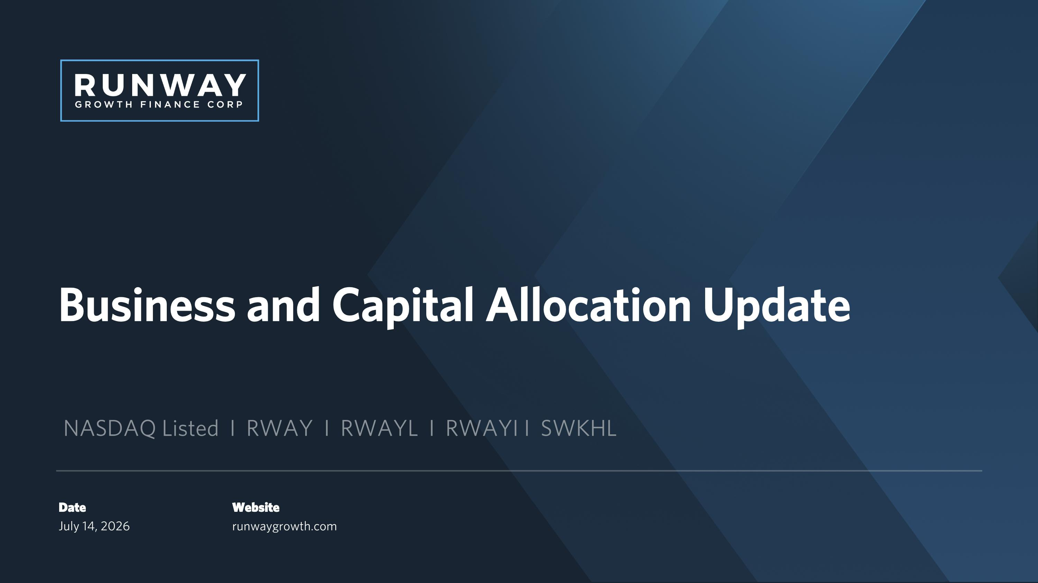
Business and Capital Allocation Update NASDAQ Listed I RWAY I RWAYL I RWAYI I SWKHL Website runwaygrowth.com Date?July 14, 2026

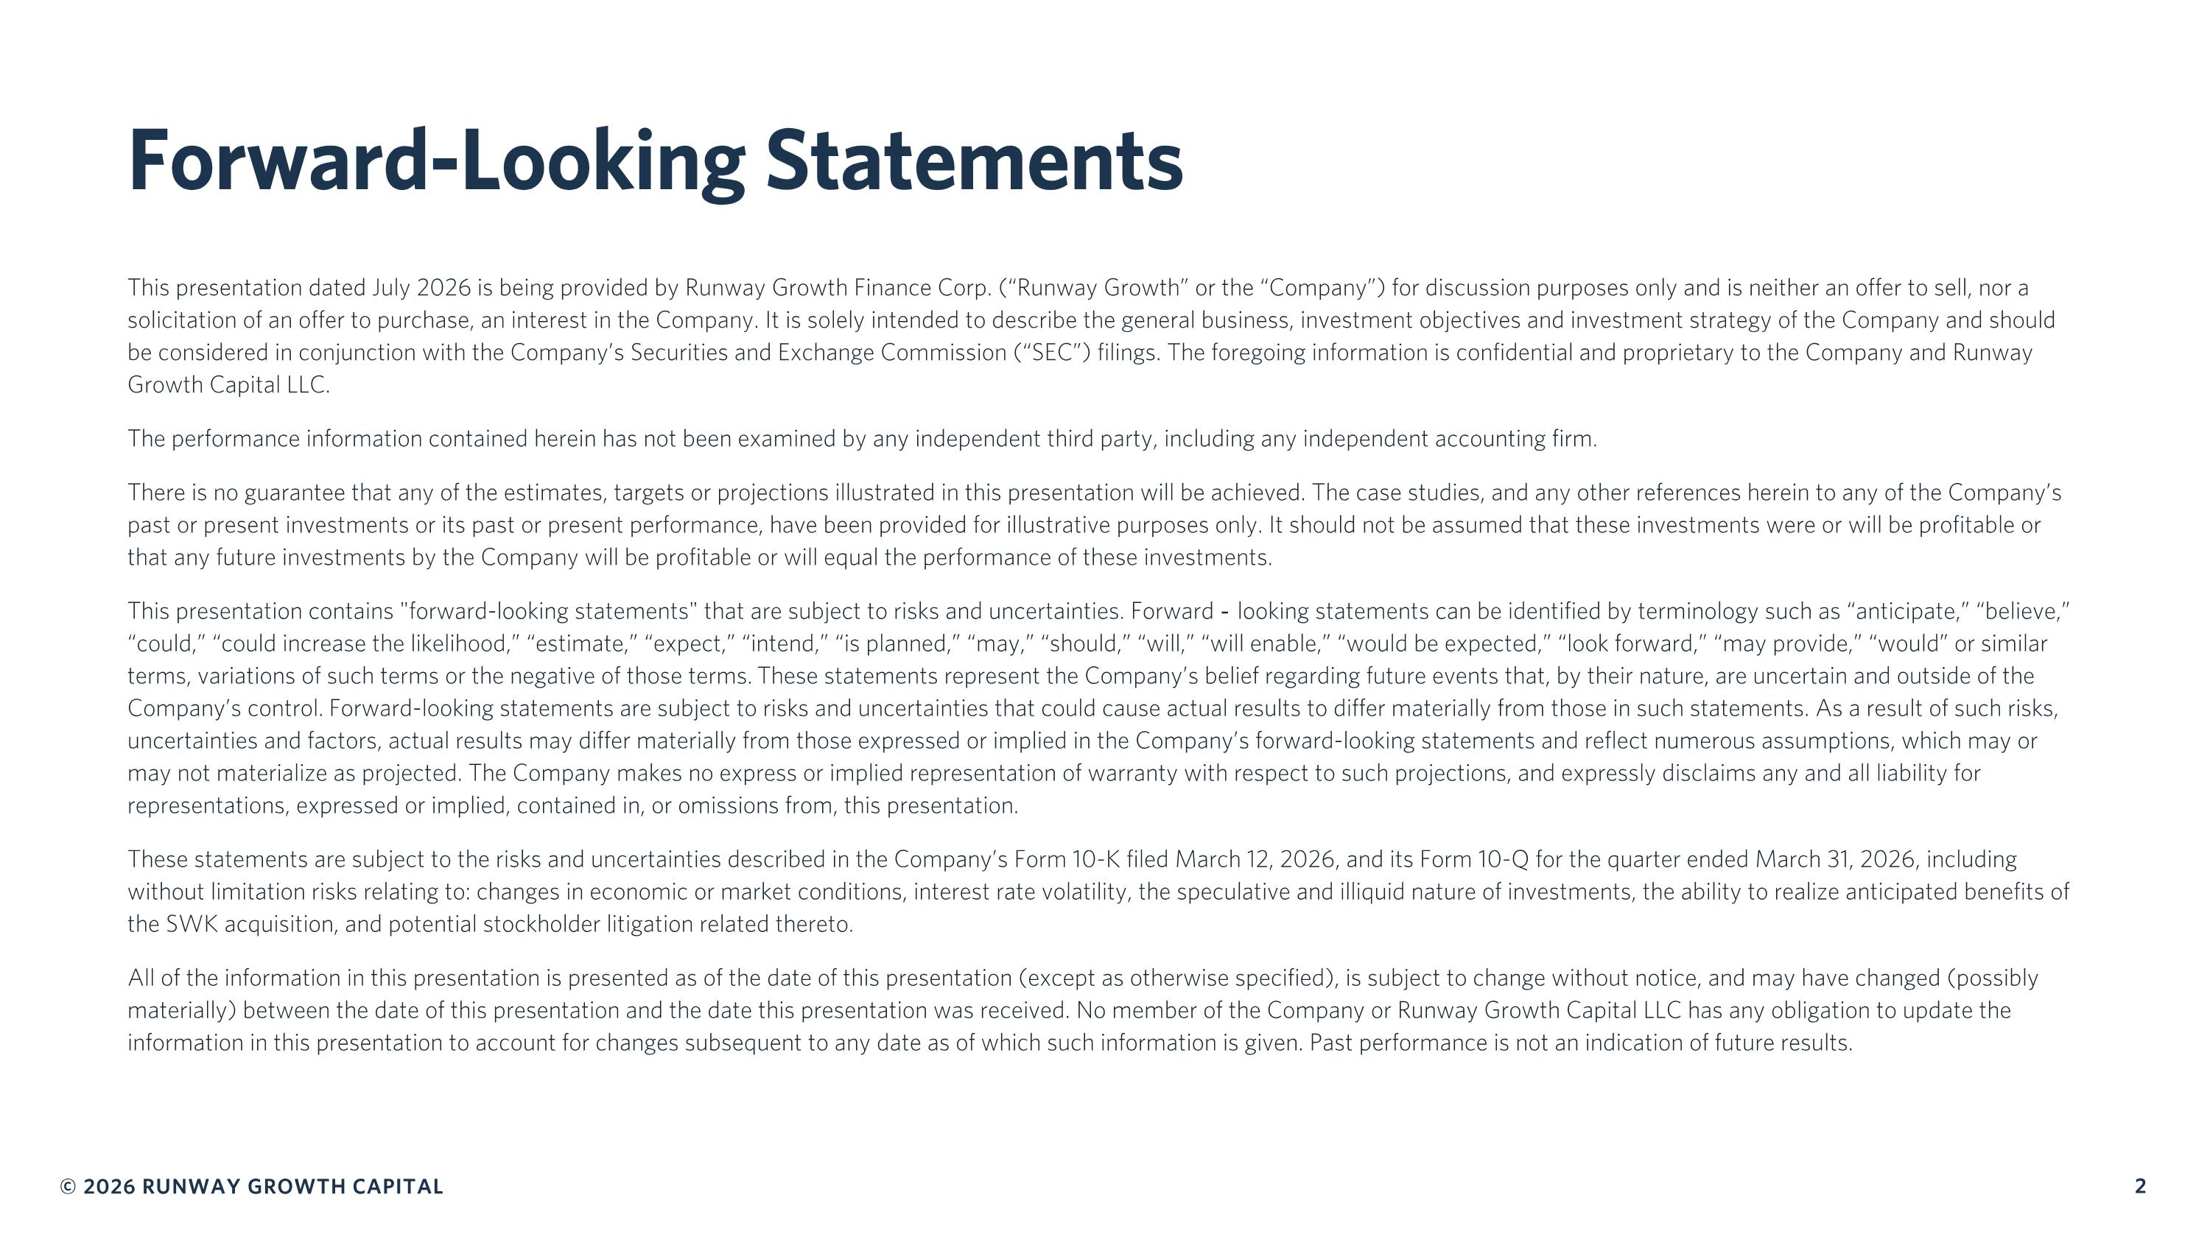
Forward-Looking Statements This presentation dated July 2026 is being provided by Runway Growth Finance Corp. (“Runway Growth” or the “Company”) for discussion purposes only and is neither an offer to sell, nor a solicitation of an offer to purchase, an interest in the Company. It is solely intended to describe the general business, investment objectives and investment strategy of the Company and should be considered in conjunction with the Company’s Securities and Exchange Commission (“SEC”) filings. The foregoing information is confidential and proprietary to the Company and Runway Growth Capital LLC. The performance information contained herein has not been examined by any independent third party, including any independent accounting firm. There is no guarantee that any of the estimates, targets or projections illustrated in this presentation will be achieved. The case studies, and any other references herein to any of the Company’s past or present investments or its past or present performance, have been provided for illustrative purposes only. It should not be assumed that these investments were or will be profitable or that any future investments by the Company will be profitable or will equal the performance of these investments. This presentation contains "forward-looking statements" that are subject to risks and uncertainties. Forward‐looking statements can be identified by terminology such as “anticipate,” “believe,” “could,” “could increase the likelihood,” “estimate,” “expect,” “intend,” “is planned,” “may,” “should,” “will,” “will enable,” “would be expected,” “look forward,” “may provide,” “would” or similar terms, variations of such terms or the negative of those terms. These statements represent the Company’s belief regarding future events that, by their nature, are uncertain and outside of the Company’s control. Forward-looking statements are subject to risks and uncertainties that could cause actual results to differ materially from those in such statements. As a result of such risks, uncertainties and factors, actual results may differ materially from those expressed or implied in the Company’s forward-looking statements and reflect numerous assumptions, which may or may not materialize as projected. The Company makes no express or implied representation of warranty with respect to such projections, and expressly disclaims any and all liability for representations, expressed or implied, contained in, or omissions from, this presentation. These statements are subject to the risks and uncertainties described in the Company’s Form 10-K filed March 12, 2026, and its Form 10-Q for the quarter ended March 31, 2026, including without limitation risks relating to: changes in economic or market conditions, interest rate volatility, the speculative and illiquid nature of investments, the ability to realize anticipated benefits of the SWK acquisition, and potential stockholder litigation related thereto. All of the information in this presentation is presented as of the date of this presentation (except as otherwise specified), is subject to change without notice, and may have changed (possibly materially) between the date of this presentation and the date this presentation was received. No member of the Company or Runway Growth Capital LLC has any obligation to update the information in this presentation to account for changes subsequent to any date as of which such information is given. Past performance is not an indication of future results.

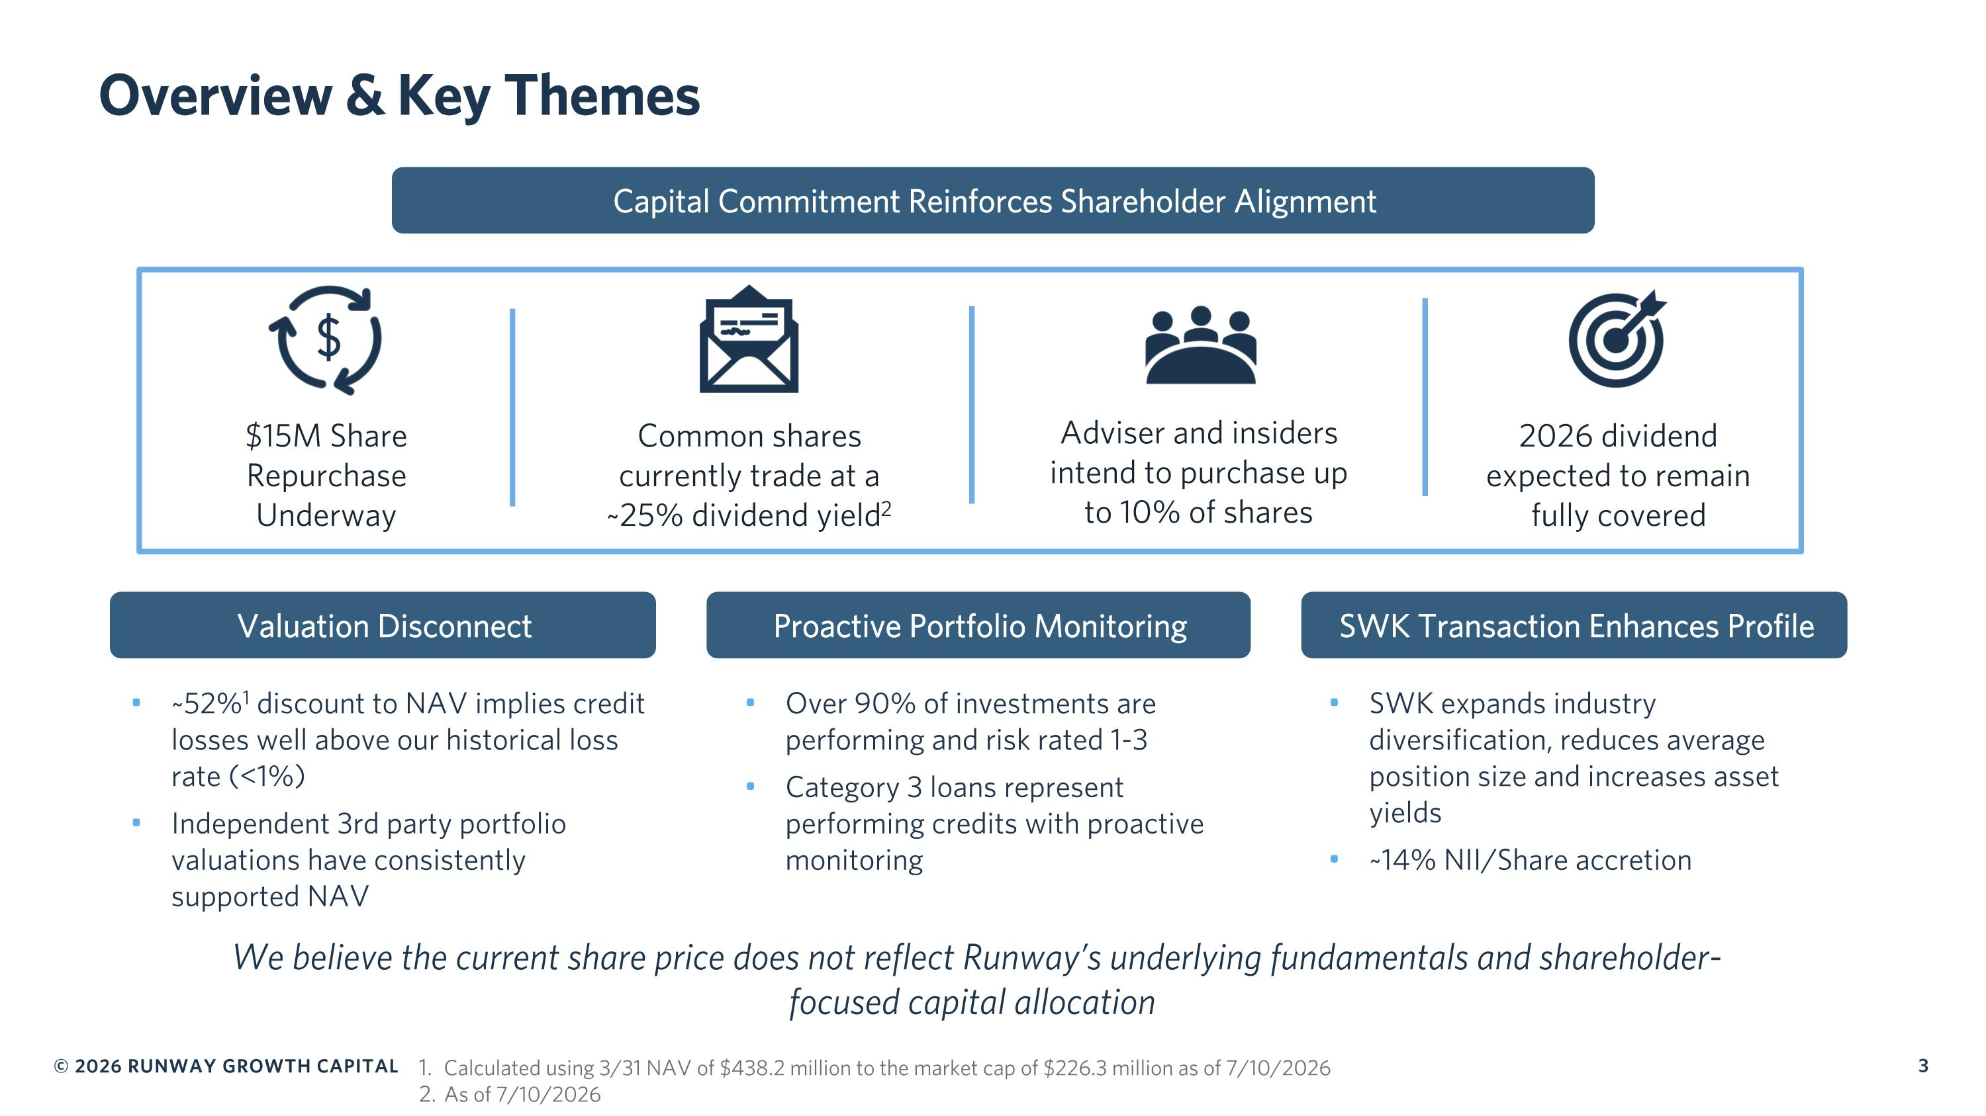
Overview & Key Themes Capital Commitment Reinforces Shareholder Alignment We believe the current share price does not reflect Runway’s underlying fundamentals and shareholder-focused capital allocation $15M Share Repurchase Underway Common shares currently trade at a ~25% dividend yield2 Adviser and insiders intend to purchase up to 10% of shares 2026 dividend expected to remain fully covered Valuation Disconnect Proactive Portfolio Monitoring SWK Transaction Enhances Profile ~52%1 discount to NAV implies credit losses well above our historical loss rate (<1%) Independent 3rd party portfolio valuations have consistently supported NAV Over 90% of investments are performing and risk rated 1-3 Category 3 loans represent performing credits with proactive monitoring SWK expands industry diversification, reduces average position size and increases asset yields ~14% NII/Share accretion Calculated using 3/31 NAV of $438.2 million to the market cap of $226.3 million as of 7/10/2026 As of 7/10/2026

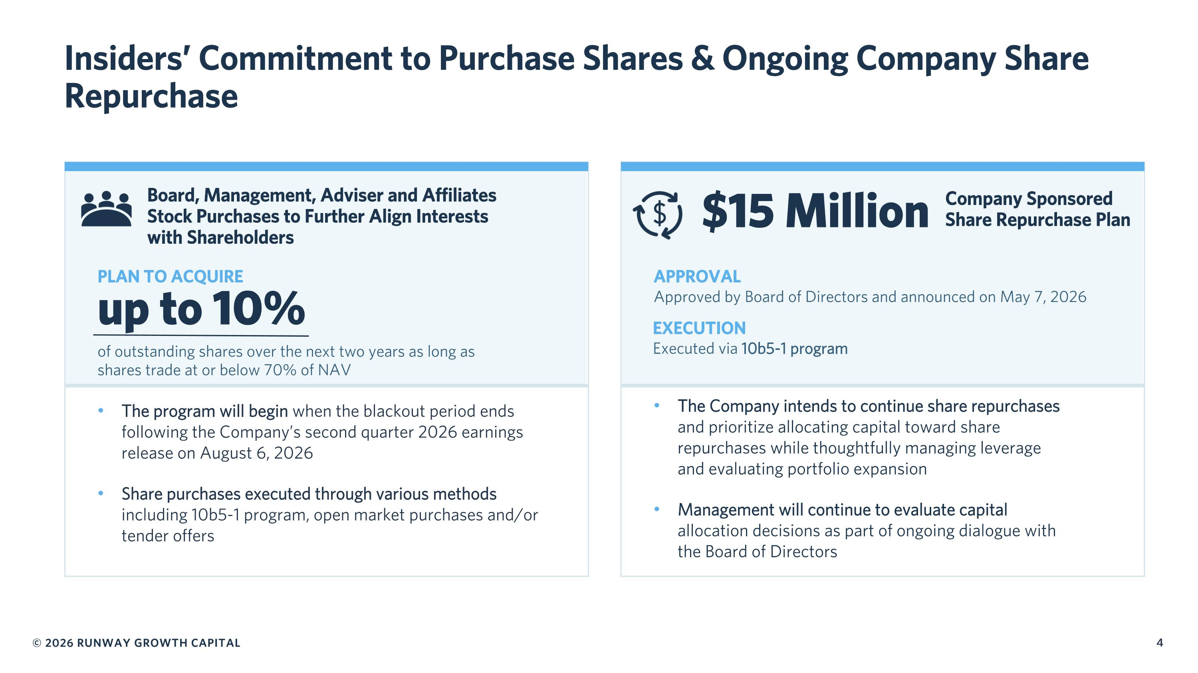
Insiders’ Commitment to Purchase Shares & Ongoing Company Share Repurchase up to 10% The program will begin when the blackout period ends following the Company’s second quarter 2026 earnings release on August 6, 2026 Share purchases executed through various methods including 10b5-1 program, open market purchases and/or tender offers PLAN TO ACQUIRE of outstanding shares over the next two years as long as shares trade at or below 70% of NAV Board, Management, Adviser and Affiliates ?Stock Purchases to Further Align Interests ?with Shareholders The Company intends to continue share repurchases ?and prioritize allocating capital toward share ?repurchases while thoughtfully managing leverage ?and evaluating portfolio expansion Management will continue to evaluate capital ?allocation decisions as part of ongoing dialogue with ?the Board of Directors $15 Million Company Sponsored ?Share Repurchase Plan APPROVAL Approved by Board of Directors and announced on May 7, 2026 EXECUTION Executed via 10b5-1 program

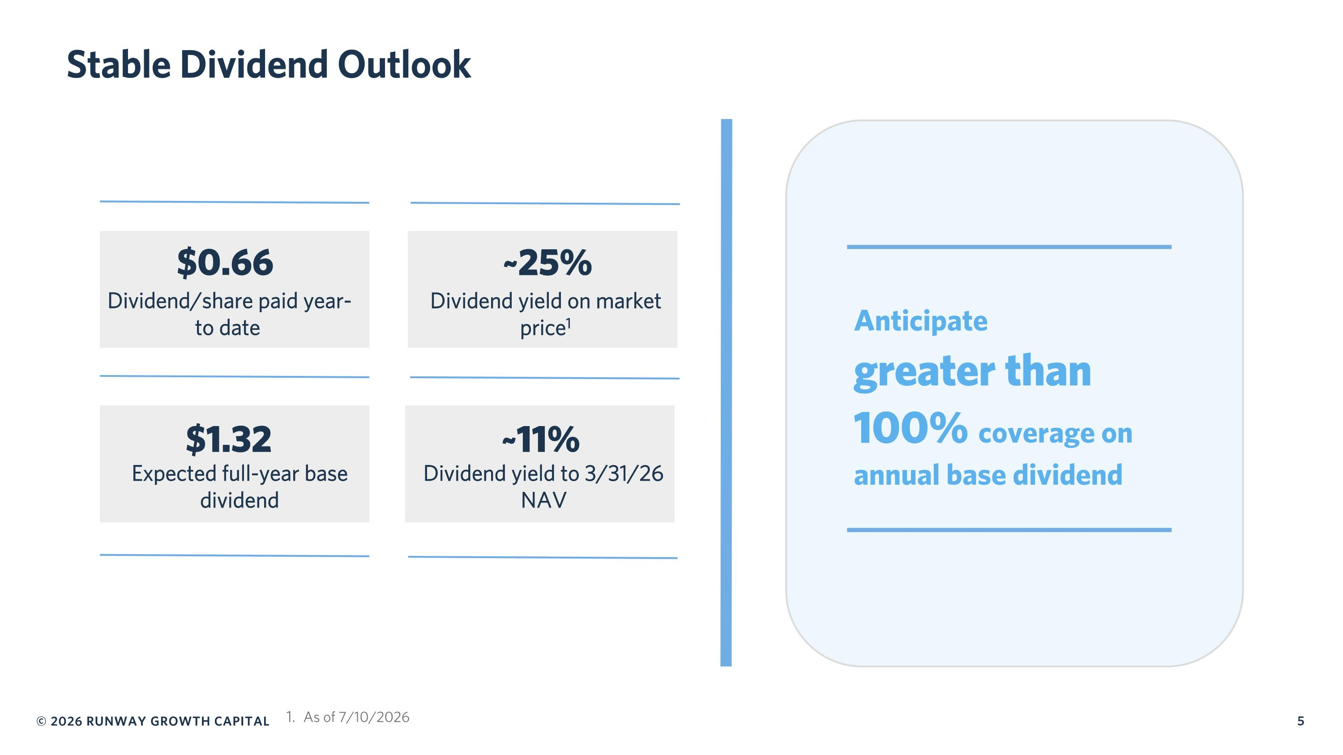
Stable Dividend Outlook Anticipate ?greater than 100% coverage on annual base dividend $0.66 Dividend/share paid year-to date $1.32 Expected full-year base dividend ~25% Dividend yield on market price1 ~11% Dividend yield to 3/31/26 NAV As of 7/10/2026

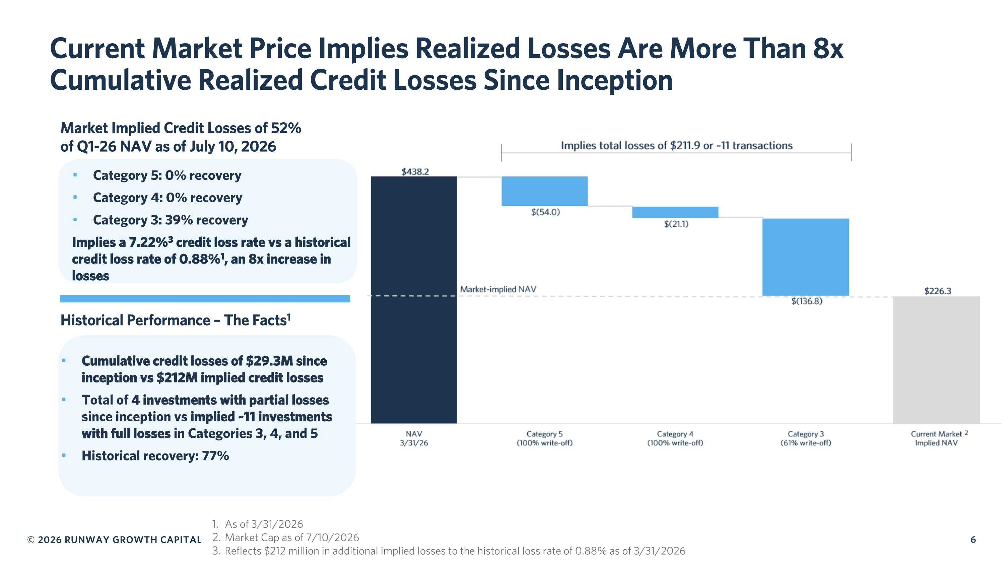
Current Market Price Implies Realized Losses Are More Than 8x Cumulative Realized Credit Losses Since Inception Historical Performance – The Facts1 Category 5: 0% recovery Category 4: 0% recovery Category 3: 39% recovery Implies a 7.22%3 credit loss rate vs a historical credit loss rate of 0.88%1, an 8x increase in losses Cumulative credit losses of $29.3M since inception vs $212M implied credit losses Total of 4 investments with partial losses since inception vs implied ~11 investments with full losses in Categories 3, 4, and 5 Historical recovery: 77% As of 3/31/2026 Market Cap as of 7/10/2026 Reflects $212 million in additional implied losses to the historical loss rate of 0.88% as of 3/31/2026 Market Implied Credit Losses of 52% of Q1-26 NAV as of July 10, 2026

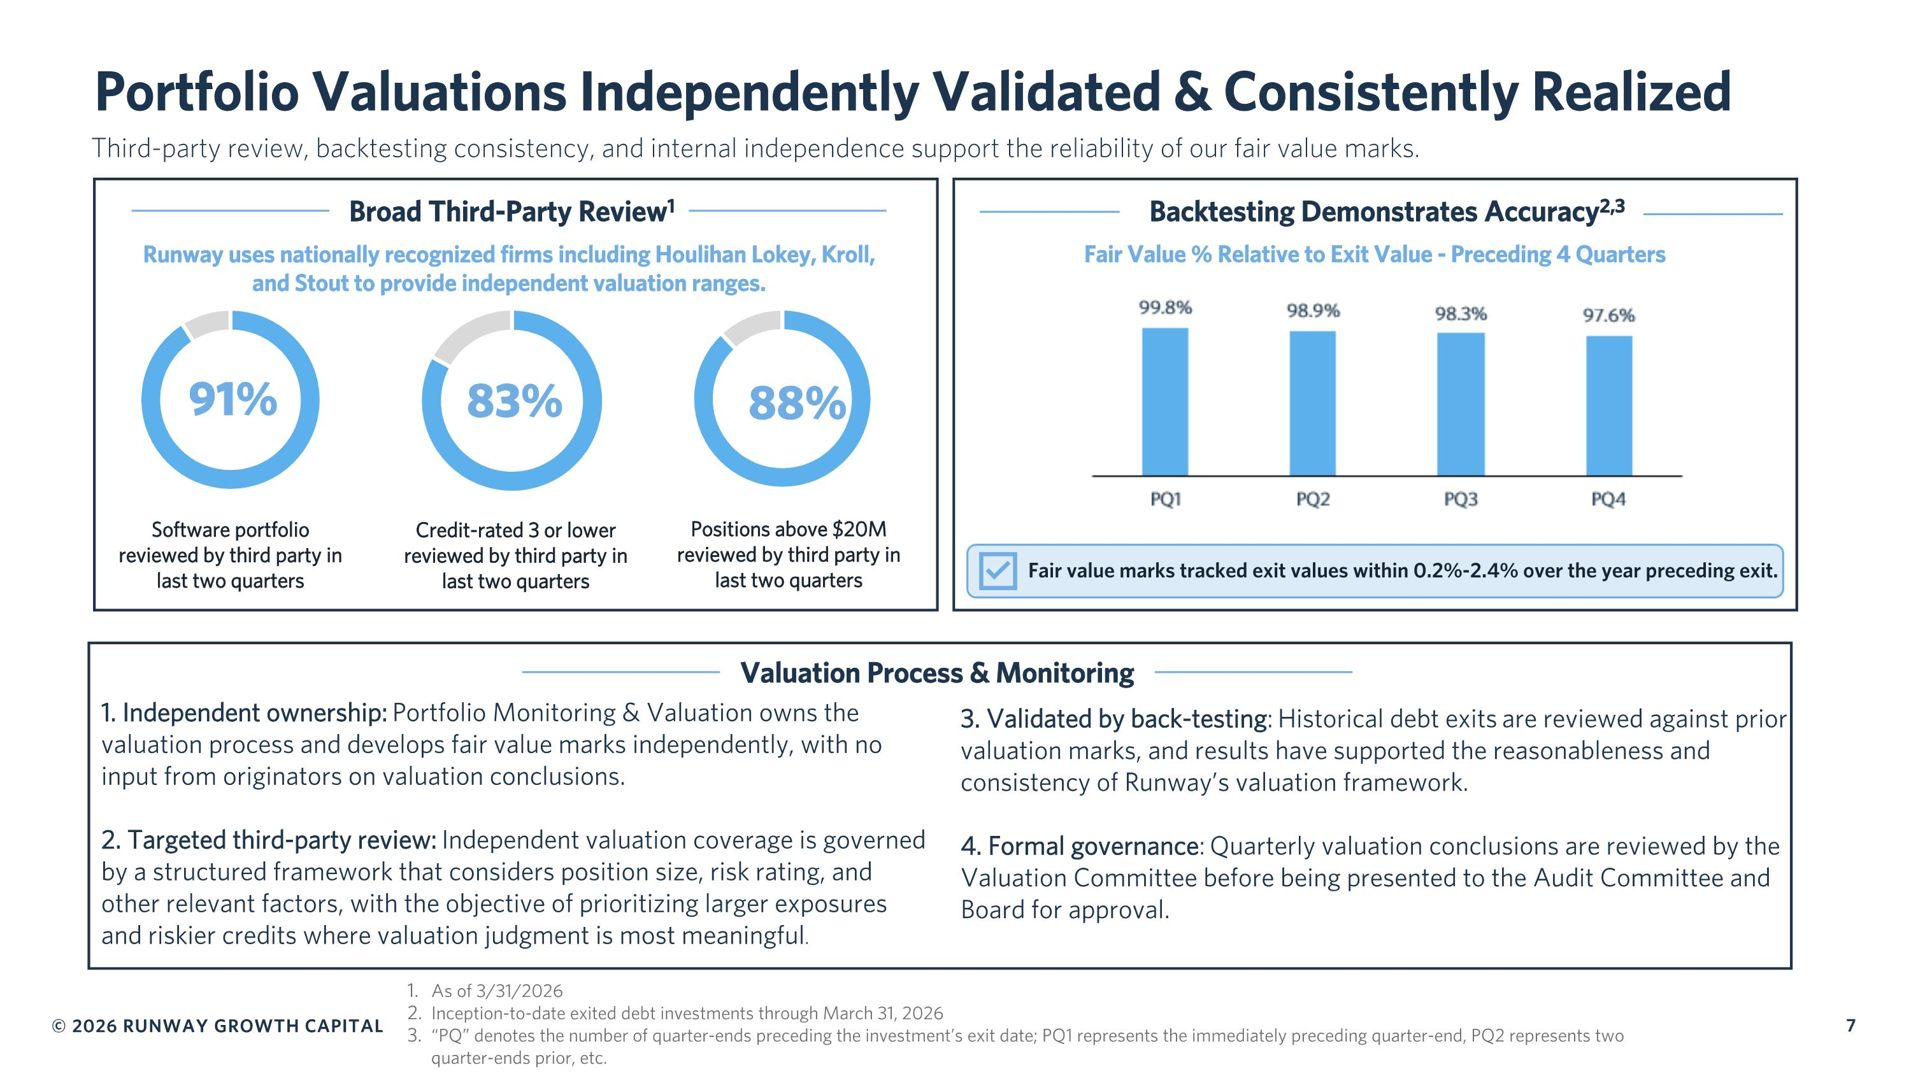
Portfolio Valuations Independently Validated & Consistently Realized Broad Third-Party Review1 Backtesting Demonstrates Accuracy2,3 Third-party review, backtesting consistency, and internal independence support the reliability of our fair value marks. Fair value marks tracked exit values within 0.2%-2.4% over the year preceding exit. 1. Independent ownership: Portfolio Monitoring & Valuation owns the valuation process and develops fair value marks independently, with no input from originators on valuation conclusions. 2. Targeted third-party review: Independent valuation coverage is governed by a structured framework that considers position size, risk rating, and other relevant factors, with the objective of prioritizing larger exposures and riskier credits where valuation judgment is most meaningful. Software portfolio reviewed by third party in last two quarters Credit-rated 3 or lower reviewed by third party in last two quarters Positions above $20M reviewed by third party in last two quarters 91% 83% 88% Fair Value % Relative to Exit Value - Preceding 4 Quarters Runway uses nationally recognized firms including Houlihan Lokey, Kroll, and Stout to provide independent valuation ranges. As of 3/31/2026 Inception-to-date exited debt investments through March 31, 2026 “PQ” denotes the number of quarter-ends preceding the investment’s exit date; PQ1 represents the immediately preceding quarter-end, PQ2 represents two quarter-ends prior, etc. 3. Validated by back-testing: Historical debt exits are reviewed against prior valuation marks, and results have supported the reasonableness and consistency of Runway’s valuation framework. 4. Formal governance: Quarterly valuation conclusions are reviewed by the Valuation Committee before being presented to the Audit Committee and Board for approval. Valuation Process & Monitoring

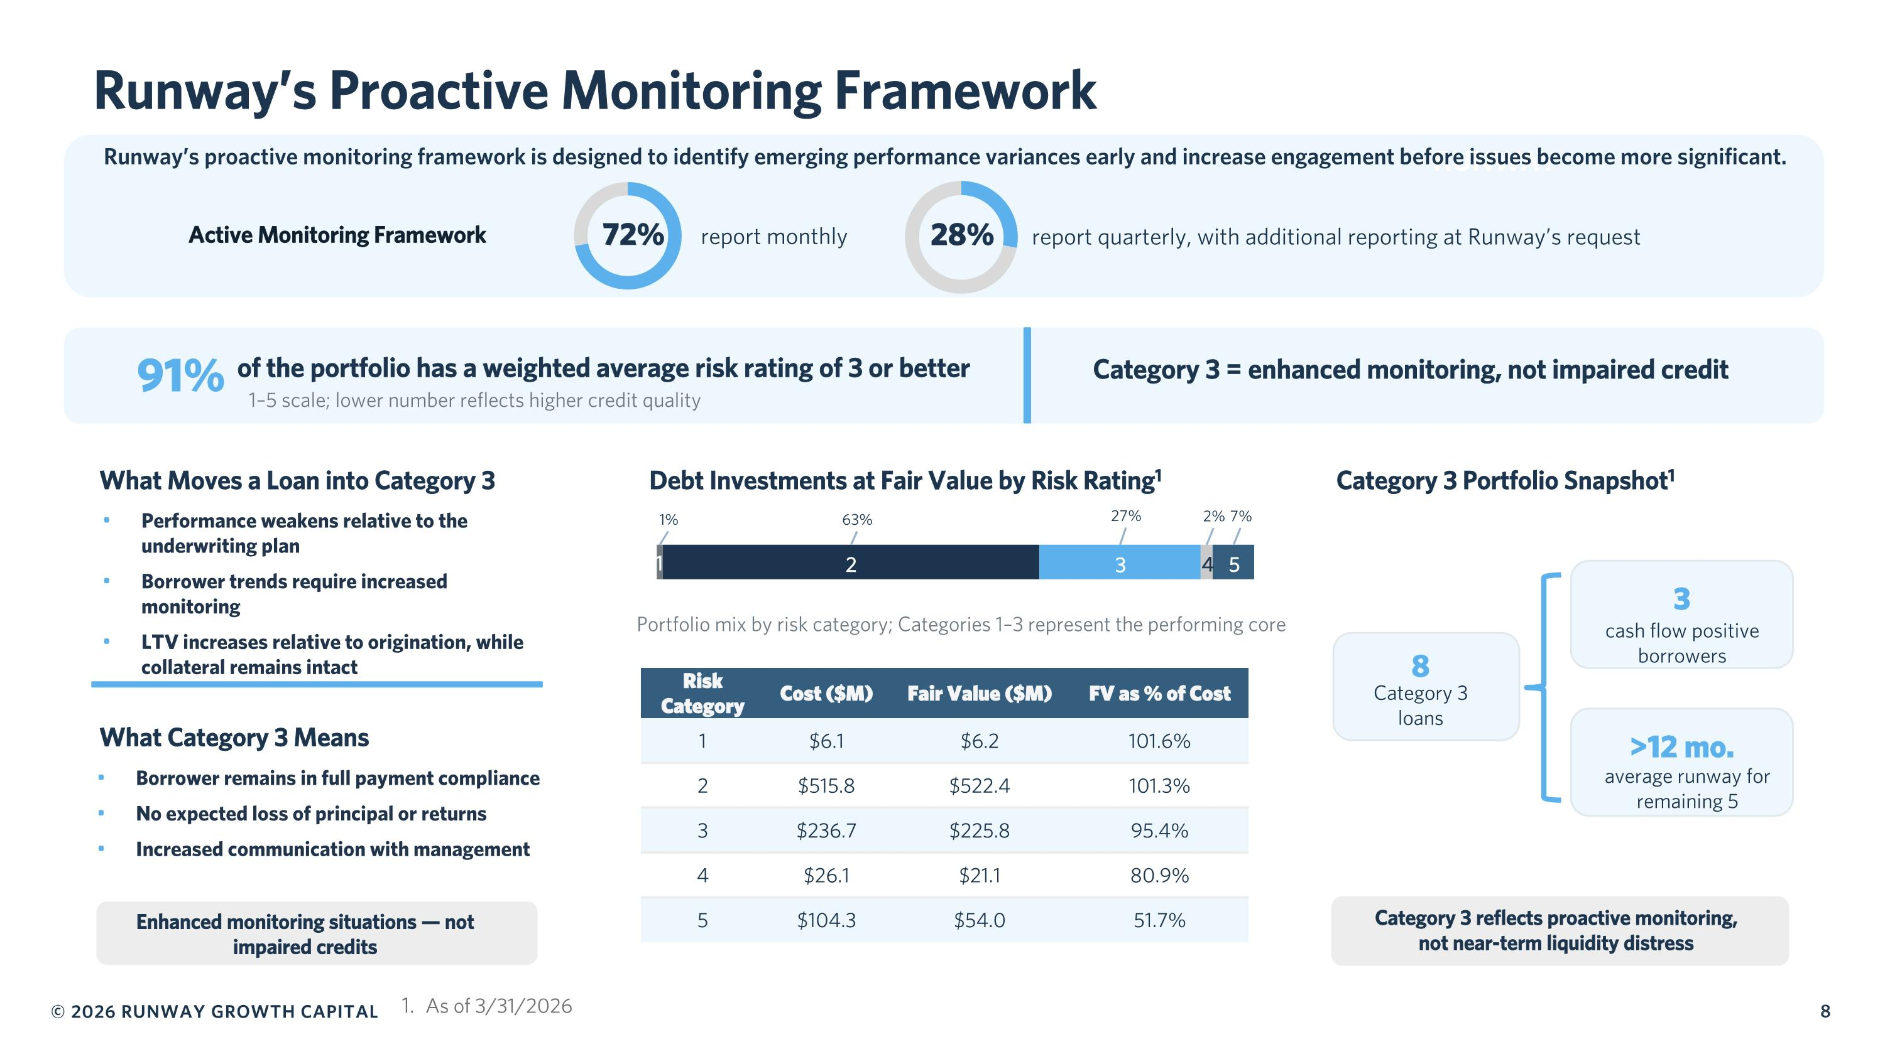
1 2 3 4 5 RUNWAY 91% of the portfolio has a weighted average risk rating of 3 or better 1–5 scale; lower number reflects higher credit quality Category 3 = enhanced monitoring, not impaired credit What Moves a Loan into Category 3 Performance weakens relative to the underwriting plan Borrower trends require increased monitoring LTV increases relative to origination, while collateral remains intact What Category 3 Means Borrower remains in full payment compliance No expected loss of principal or returns Increased communication with management Enhanced monitoring situations — not impaired credits Debt Investments at Fair Value by Risk Rating1 Portfolio mix by risk category; Categories 1–3 represent the performing core Category 3 Portfolio Snapshot1 8 Category 3 loans 3 cash flow positive borrowers >12 mo. average runway for remaining 5 Category 3 reflects proactive monitoring, not near-term liquidity distress Active Monitoring Framework report monthly report quarterly, with additional reporting at Runway’s request Runway’s proactive monitoring framework is designed to identify emerging performance variances early and increase engagement before issues become more significant. Runway’s Proactive Monitoring Framework Risk Category Cost ($M) Fair Value ($M) FV as % of Cost 1 $6.1 $6.2 101.6% 2 $515.8 $522.4 101.3% 3 $236.7 $225.8 95.4% 4 $26.1 $21.1 80.9% 5 $104.3 $54.0 51.7% 72% 28% 8 As of 3/31/2026

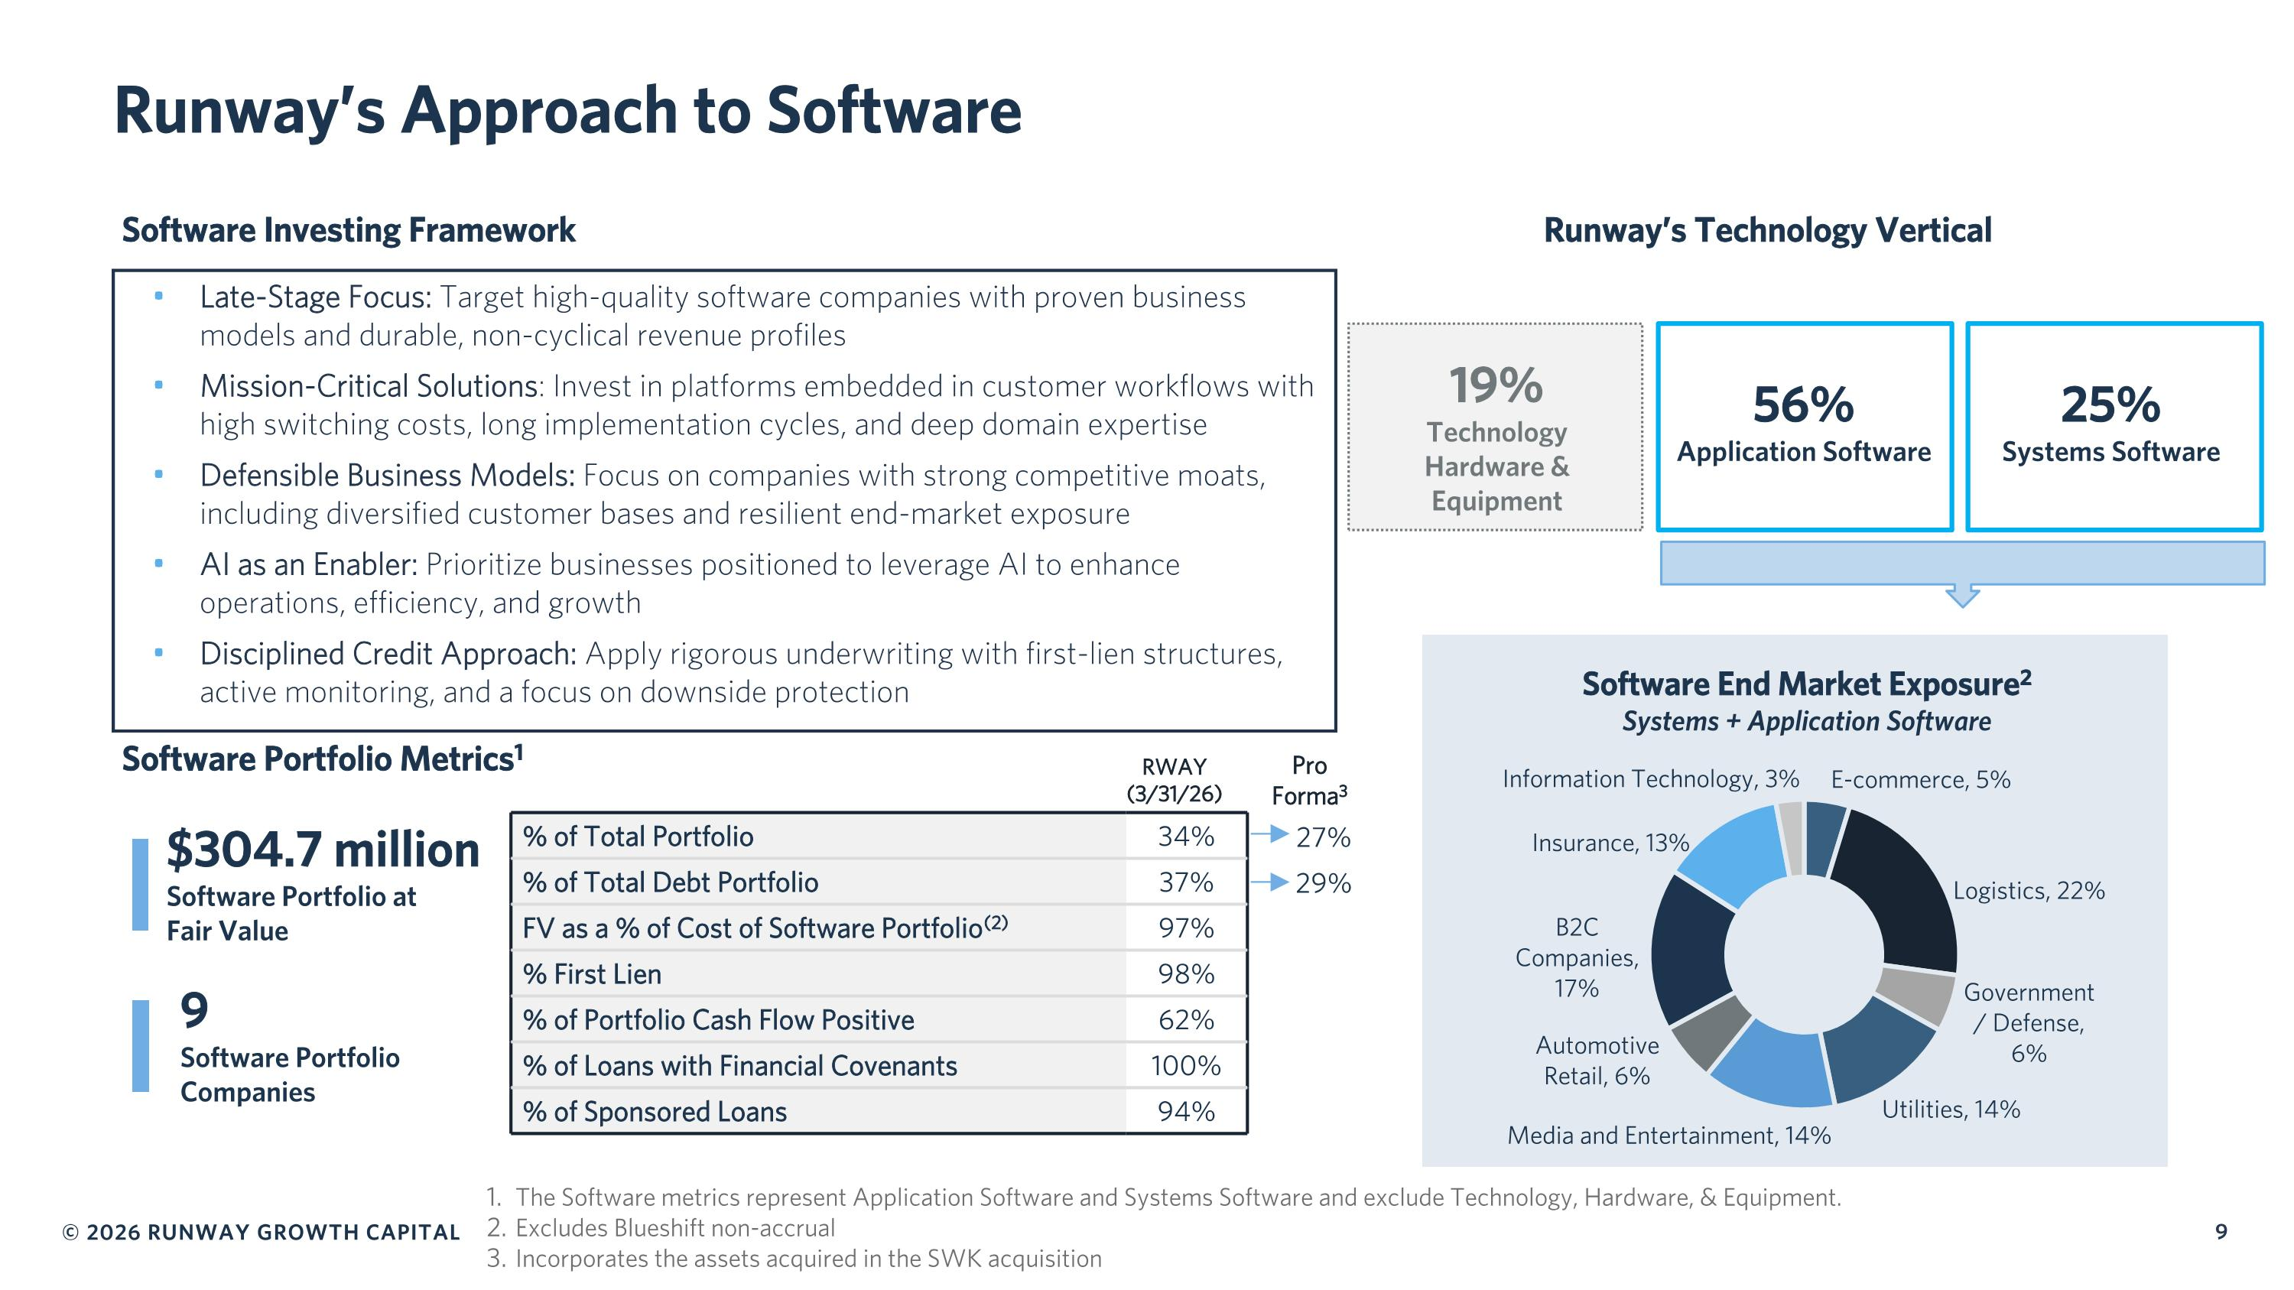
Runway’s Approach to Software The Software metrics represent Application Software and Systems Software and exclude Technology, Hardware, & Equipment. Excludes Blueshift non-accrual Incorporates the assets acquired in the SWK acquisition % of Total Portfolio 34% % of Total Debt Portfolio 37% FV as a % of Cost of Software Portfolio(2) 97% % First Lien 98% % of Portfolio Cash Flow Positive 62% % of Loans with Financial Covenants 100% % of Sponsored Loans 94% Software Portfolio Metrics1 $304.7 million Software Portfolio at Fair Value 9 Software Portfolio Companies Software Investing Framework Late-Stage Focus: Target high-quality software companies with proven business models and durable, non-cyclical revenue profiles Mission-Critical Solutions: Invest in platforms embedded in customer workflows with high switching costs, long implementation cycles, and deep domain expertise Defensible Business Models: Focus on companies with strong competitive moats, including diversified customer bases and resilient end-market exposure AI as an Enabler: Prioritize businesses positioned to leverage AI to enhance operations, efficiency, and growth Disciplined Credit Approach: Apply rigorous underwriting with first-lien structures, active monitoring, and a focus on downside protection Software End Market Exposure2 Systems + Application Software RWAY?(3/31/26) Pro Forma3 Runway’s Technology Vertical 27% 29% 19% Technology Hardware & Equipment 56% Application Software 25% Systems Software

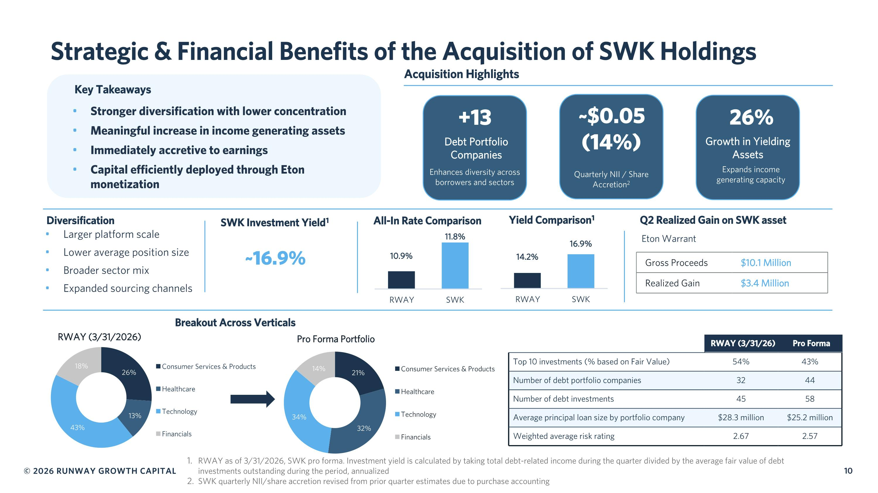
Strategic & Financial Benefits of the Acquisition of SWK Holdings Acquisition Highlights Debt Portfolio Companies Enhances diversity across borrowers and sectors ~$0.05 (14%) Quarterly NII / Share Accretion2 Growth in Yielding Assets Expands income generating capacity Diversification Larger platform scale Lower average position size Broader sector mix Expanded sourcing channels SWK Investment Yield1 ~16.9% Breakout Across Verticals RWAY (3/31/2026) Pro Forma Portfolio Q2 Realized Gain on SWK asset Eton Warrant Gross Proceeds $10.1 Million Realized Gain $3.4 Million Key Takeaways Stronger diversification with lower concentration Meaningful increase in income generating assets Immediately accretive to earnings Capital efficiently deployed through Eton monetization All-In Rate Comparison Yield Comparison1 RWAY as of 3/31/2026, SWK pro forma. Investment yield is calculated by taking total debt-related income during the quarter divided by the average fair value of debt investments outstanding during the period, annualized SWK quarterly NII/share accretion revised from prior quarter estimates due to purchase accounting +13 26% RWAY (3/31/26) Pro Forma Top 10 investments (% based on Fair Value) 54% 43% Number of debt portfolio companies 32 44 Number of debt investments 45 58 Average principal loan size by portfolio company $28.3 million $25.2 million Weighted average risk rating 2.67 2.57

